CyberSnare: Multi-Tier Adaptive Deception Platform

A project submitted in partial fulfillment of the degree of
BS in Cyber Security

Submitted to
Mr. Hilmand Khan
Part A: STUDENT INFORMATION
Name: | Eman Azam |  |  |  | Registration: | 233042
Email: | 233042@students.au.edu.pk
Name: | Sara Sultan |  |  |  | Registration: | 232075
Email: | 232075@students.au.edu.pk
Name: | Uliya Fatima |  |  |  | Registration: | 232098
Email: | 232098@students.au.edu.pk
Part B: PROJECT INFORMATION
Project Name: |  | CyberSnare
Project Title: |  | Multi-Tier Adaptive Deception Platform
Project Area: |  | Network Security / Cyber Deception Systems |  | End Users: | Security analysts (SOC  teams),cybersecurity researchers, and  organizational IT security team
Project Type: |  | ✔ Research | ✔ Development | Technology: | ✔ Based | □ Structured
Platform: |  | □ Desktop | Web App | □ Mobile App | □ Distributed | □ Others
If Others:

Part C: SUPERVISOR INFORMATION
Signature: |  | Signature:
Supervisor: | Mr. Hilmand Khan | Co-Supervisor: | Mr. Jalal Shah

Part D: FOR OFFICE USE ONLY
Decision: | Approved | Approved (Minor) | Approved (Major) |  | Rejected
Comment:
Reviewer: |  |  | Reviewer Signature | Authorized Signature

1.Abstract
CyberSnare is a research-grade adaptive cyber deception platform that detects, engages, and analyses malicious network activity through a dynamically escalating series of deceptive environments. Unlike conventional security systems that block threats at the perimeter, CyberSnare allows attackers to interact with a carefully constructed false network while their every action is observed, scored, and recorded in real time.
The platform operates across three escalating tiers of deception, each triggered automatically by a behavioural scoring engine. Lightweight decoy services form the outermost layer. As attacker engagement intensifies, the system provisions medium-interaction honeypots, including a customised Cowrie SSH environment and a fake web application and ultimately a high-interaction simulated enterprise environment complete with AI-generated documents, forged filesystem histories, fake credentials, and a convincing internal network topology, all orchestrated through Kubernetes.
The AI-powered artifact generation module produces contextually consistent fake organisational content timestamped to appear months or years old. A dynamic containment engine prevents attacker escape using iptables, network namespaces, and traffic shaping. All activity feeds into an ELK Stack SIEM, featuring automatic MITRE ATT&CK mapping, session replay, and automated PDF incident reports. The platform is evaluated through red team simulations across three attacker profiles, producing measurable deception effectiveness metrics as an original research contribution.

Table of Contents
1.Abstract 4
2. Introduction 6
2.1 Motivation 6
2.2 Problem Context 7
2.3 Proposed Approach 7
3. Background 8
3.1 Honeypot Classification 8
3.2 The Limitations of Static Deception 8
3.3 Containerisation and Kubernetes as Infrastructure Primitives 9
3.4 Large Language Models and AI-Generated Content 9
3.5 The MITRE ATT&CK Framework 10
3.6 Containerisation and Kubernetes 11
4. Literature Review 11
4.1Comparative Honeypot Evaluation 11
4.2 Adaptive and Dynamic Honeypot Systems 12
4.3 Machine Learning Integration 13
4.4 Credential Analysis and Real-World Attacker Behaviour 13
4.5 LLM-Assisted Environmental Realism 14
4.6 Research Gap Analysis 14
5. Problem Statement 15
5.1 The Core Problem 15
5.2 Research Questions 16
6. Objectives 16
6.1 Primary Aim 16
6.2 Specific Objectives 16
7. Proposed Methodology 17
8. High-Level System Components 18
8.1 Recon Detection Engine 19
8.2 Behaviour Scoring Engine 20
8.3 Deception Controller 20
8.4 Kubernetes Orchestrator 20
8.5 AI Artifact Generator 20
8.6 Dynamic Containment Engine 21
8.7 SIEM and Intelligence Platform 21
9. Use Case Diagram 22
10. Results and Experiments 23
10.1 Research and Conceptual Outcomes 23
10.2 Challenges Identified and Addressed 24
11. Tools and Technologies 24
11.1 Infrastructure 24
11.2 Containerisation and Orchestration 25
11.3 Network Detection 25
11.4 Honeypot Components 26
11.5 Behavioural Analysis and Orchestration 26
11.6 AI Artifact Generation 26
11.7 Dynamic Containment 27
11.8 SIEM and Intelligence 27
12. Sustainable Development Goals 28
13. Gantt Chart 29
14. Expertise of Team Members 29
15. References: 31

2. Introduction

2.1 Motivation
The cybersecurity landscape has undergone a fundamental shift in recent years. Organisations of all sizes increasingly face sophisticated threat actors who are patient, methodical, and specifically trained to evade traditional perimeter defences. Firewalls, intrusion prevention systems, and signature-based detection tools remain essential components of any security architecture, but they share a critical and well-documented weakness, they are informationally poor. When a threat is blocked at the boundary, the defender learns almost nothing about the attacker's tools, objectives, skill level, or methodology.
Cyber deception offers a fundamentally different approach to this problem. Rather than denying access entirely, a deception platform presents convincing false targets, services, files, credentials, and entire network segments, and uses the attacker's own activity as intelligence. Every command an attacker executes, every file they open, every connection they attempt, and every pivot they try reveals actionable information about their techniques, tools, and intentions.
CyberSnare is built on this principle. It brings together behavioural analysis, Kubernetes-based elastic infrastructure, AI-generated environmental content, dynamic network containment, and structured threat intelligence output into a single integrated platform that addresses the specific limitations of existing open-source honeypot tooling.

2.2 Problem Context
Despite decades of honeypot research, open-source tools suffer from four interconnected limitations.
Limitation 1: Static and non-adaptive deployment. Tools like Cowrie and OpenCanary run as fixed services. They do not adapt to attacker behaviour or escalate based on engagement. A skilled attacker fingerprints and abandons them within minutes, yielding minimal intelligence.
Limitation 2: Poor environmental realism. Medium-interaction honeypots present sparse, artificial filesystems. No documents, no shell histories, no aged logs. Real servers accumulate months of evidence, its absence is a clear detection signal that dramatically reduces engagement duration.
Limitation 3: Infrastructure inflexibility. Most deployments are manually provisioned with no on-demand scaling, no session isolation, and no automated rebuild after compromise. Concurrent sessions risk cross-contamination, and the system cannot respond dynamically to attack volume.
Limitation 4: Insufficient threat intelligence output. Most honeypots produce raw logs requiring manual analysis. No automated MITRE ATT&CK correlation, no attacker profiling, and no quantitative deception effectiveness measurement. The gap between raw telemetry and actionable intelligence remains wide.
CyberSnare addresses all four limitations through a single integrated platform.

2.3 Proposed Approach
CyberSnare implements three escalating deception tiers triggered by a real-time behavioural scoring engine that tracks attacker activity. Kubernetes manages the full honeypot lifecycle, provisioning environments on demand, isolating concurrent sessions, and destroying them automatically after each engagement. An AI-powered module generates internally consistent fake organizational content that makes the highest deception tier convincingly realistic. A dynamic containment engine prevents any lateral movement or data exfiltration from escaping the deception environment. All activity is captured in a centralized SIEM pipeline with automatic MITRE ATT&CK mapping, delivering actionable intelligence rather than raw logs.

3. Background

3.1 Honeypot Classification
Honeypots are classified along two primary axes, purpose and interaction level.
By Purpose:
Type | Description | Primary Use
Research honeypot | Studies attacker behaviour and new attack techniques | Academic research, threat intelligence
Production honeypot | Defends operational networks by diverting and detecting attackers | Enterprise security operations

By Interaction Level:
Level | Description | Examples | Risk Level
Low-interaction | Emulates specific services without real OS access | Honeyd, OpenCanary | Low
Medium-interaction | Provides emulated shell environment, logs commands | Cowrie, Kippo | Medium
High-interaction | Real operating system accessible to attacker | Actual Linux containers, VMware VMs | High
Hybrid | Combines low and high-interaction layers with escalation | CyberSnare Tier 1-3 | Managed

3.2 The Limitations of Static Deception
The static nature of traditional honeypot deployments creates several well-documented problems that limit their effectiveness against sophisticated adversaries.
Traditional honeypot deployments fail against sophisticated attackers in three specific ways:
Fingerprinting: Cowrie and similar tools have documented fingerprints. An attacker checking /proc/self/cgroup, CPU count, memory values, or Python process signatures can identify a honeypot within minutes and disengage without providing meaningful intelligence.
Environmental sparseness: Real servers accumulate months of log entries, shell history, installed packages, configuration changes, and user-generated files. A freshly deployed honeypot with an empty filesystem and no history is immediately recognisable to any careful observer.
Infrastructure limitations: Manual provisioning cannot scale in response to simultaneous attack volume. Shared environments risk cross-session contamination. There is no automated recovery after compromise.

3.3 Containerisation and Kubernetes as Infrastructure Primitives
The emergence of Docker containerisation in 2013 and Kubernetes orchestration in 2014 introduced infrastructure primitives that fundamentally change what is possible in honeypot deployment. Containers provide lightweight, isolated execution environments that can be created and destroyed in seconds. Kubernetes adds automated lifecycle management, scaling, networking isolation through namespaces and network policies, and a declarative API for describing desired state that allows complex infrastructure to be managed programmatically.
For honeypot platforms, these capabilities address the scalability and isolation limitations of static deployment directly. A Kubernetes-based honeypot controller can spawn a new, clean honeypot environment for each attacker session, isolate it completely from concurrent sessions through namespace separation, and destroy it automatically when the session ends, all without manual intervention. The environment destruction and rebuild cycle also addresses the environmental contamination problem: each new attacker always sees a fresh, uncorrupted environment.
gVisor, released by Google in 2018, provides a user-space kernel that intercepts system calls made by container processes before they reach the host kernel.

3.4 Large Language Models and AI-Generated Content
The availability of large language model APIs beginning in 2020 and accelerating through 2022 and 2023 introduced a capability directly relevant to honeypot environmental realism. LLMs can generate contextually appropriate prose content, business documents, email correspondence, technical reports, log entries, that is statistically indistinguishable from human-written content to automated classifiers and plausible to human readers.
For honeypot environments, this capability addresses the environmental sparseness limitation. Instead of manually crafting a fake company's documents, an LLM API can generate hundreds of internally consistent fake memos, reports, emails, and configuration files referencing a coherent fake organisational identity. Python libraries such as Faker can generate structured fake data, employee records, customer databases, financial figures, that complement the prose content. Combined with filesystem timestamp manipulation using libfaketime and the Linux touch command, these generated artifacts can be made to appear months or years old, creating an environment that looks genuinely lived-in.
Content Type | Generation Method | Consistency Mechanism
Internal memos, reports, emails | LLM API with company profile context | Master profile JSON passed to every call
Employee records, customer databases | Python Faker with profile-constrained names | Same name pool derived from profile
Shell histories, log files | Template engine with timestamp arithmetic | Timestamps calculated backwards from deployment date
Database SQL dumps | SQL templates with Faker records | Foreign key relationships enforced by templates
Filesystem timestamps | libfaketime + touch -t + debugfs | atime, mtime, ctime all manipulated consistently

3.5 The MITRE ATT&CK Framework
The MITRE ATT&CK framework, initially published in 2013 and continuously updated, provides a structured taxonomy of adversary tactics, techniques, and procedures derived from real-world observations of threat actor behaviour. The framework organises techniques under tactical categories including Reconnaissance, Initial Access, Execution, Persistence, Privilege Escalation, Defence Evasion, Credential Access, Discovery, Lateral Movement, Collection, Command and Control, and Exfiltration
Tactic | ID | Relevance to CyberSnare
Reconnaissance | TA0043 | Detected at Tier 1 scanning and probing
Initial Access | TA0001 | Detected at login attempts on all tiers
Execution | TA0002 | Logged in Cowrie and Tier 3 auditd
Persistence | TA0003 | Detected through crontab and SSH key attempts
Privilege Escalation | TA0004 | Mapped from sudo and exploit commands
Credential Access | TA0006 | Mapped from /etc/passwd, /etc/shadow reads
Discovery | TA0007 | Mapped from hostname, whoami, ifconfig commands
Lateral Movement | TA0008 | Detected through internal connection attempts
Collection | TA0009 | Detected through file browsing and archive creation
Exfiltration | TA0010 | Detected at containment engine all blocked

3.6 Containerisation and Kubernetes
Docker (2013) and Kubernetes (2014) introduced infrastructure primitives that fundamentally change what honeypot deployment can achieve.
Capability | Kubernetes Feature | CyberSnare Application
On-demand environment creation | Pod Jobs | Tier 2 and 3 instances provisioned per attacker session
Session isolation | Network namespaces and Network Policies | Concurrent sessions cannot observe each other
Automated lifecycle | Pod restart and deletion policies | Environments destroy and rebuild automatically
Lightweight operation | k3s distribution (under 512MB RAM) | Feasible on academic lab hardware
Container security hardening | gVisor (runsc) runtime | System call interception prevents host kernel exposure

4. Literature Review

4.1Comparative Honeypot Evaluation
Morić, Dakić, and Regvart (2025) conducted rigorous comparative evaluation of seven honeypot solutions in a VMware ESXi testbed, assessing each across nine criteria through simulated reconnaissance, credential, and payload delivery attack scenarios.
Honeypot | Detection Scope | Data Quality | Scalability | CyberSnare Role
Dionaea | Excellent: SMB, HTTP, FTP, MySQL | Excellent: malware capture | Good | Optional malware capture extension
Cowrie | Narrow: SSH/Telnet only | Excellent: full command logging | Moderate | Core Tier 2 component, heavily customised
Honeyd | Broad:any TCP/UDP service | Basic: timestamps and IPs only | Excellent | Informs Tier 1 lightweight design
Glastopf | Web application focused | Good: web exploit capture | Moderate | Informs web honeypot design
Amun | Multi-service | Moderate | Moderate | Considered for Tier 1 supplementation
Kippo | SSH only | Good | Moderate | Historical predecessor, superseded by Cowrie
Thug | Client-side browser emulation | Excellent for web threats | Low | Out of scope

4.2 Adaptive and Dynamic Honeypot Systems
Lanz et al. (2025) conducted a systematic literature review of machine learning integration in IoT honeypots using Wohlin's snowballing methodology across 49 papers. Their analysis of HoneyShell's two-phase evolutionary deployment is directly relevant to CyberSnare. Phase 1 accepted all credential combinations to collect baseline data. Phase 2 restricted credentials to the top 30 patterns observed in Phase 1 and added custom filesystems and command responses. This phase-based evolution, where observed attacker behaviour informs subsequent environment configuration, demonstrates the value of session analytics that CyberSnare's SIEM module provides.
Their analysis of HoneyIoT's reinforcement learning implementation showed that framing attacker interactions as a Markov Decision Process and using Proximal Policy Optimisation (PPO) achieved the fastest convergence across 100 randomised attack sessions. The reward structure (+5 for malware uploads, +1 for vulnerability exploitation, -1 for other actions) directly influenced CyberSnare's behaviour scoring weights.
Kuwatly et al. (2004) proposed the first dynamic honeypot design for intrusion detection, a controller monitoring network activity and provisioning instances in response. Though predating containerisation, this conceptual architecture is directly reflected in CyberSnare's deception controller and Kubernetes orchestrator design.

4.3 Machine Learning Integration
ML Paradigm | Best Algorithms | Peak Accuracy | Limitation | CyberSnare Application
Supervised learning | Random Forest, SVM, CNN, LSTM | 96% (Random Forest) | Requires labelled data | Attacker profile classification
Unsupervised learning | K-means, DBSCAN, Isolation Forest | 100% in controlled settings | Less interpretable | Anomaly detection in scoring engine
Reinforcement learning | PPO, A2C, Q-learning | Highest simulation reward | Computationally intensive | Conceptual basis for escalation logic
The S-Pot smart honeypot framework (Franco et al., 2022) achieved 97% attack detection accuracy using the J48 algorithm with dynamic rule configuration, demonstrating that rule-based ML classifiers integrated with honeypot telemetry can achieve near-production-grade accuracy. CyberSnare's attacker profile classifier draws on this approach.

4.4 Credential Analysis and Real-World Attacker Behaviour
Rabzelj and Sedlar (2025) published the most extensive empirical analysis of attacker credential behaviour to date, analysing over 27 billion leaked credentials alongside data from 39 honeypots over one year.
Finding | Direct Implication for CyberSnare
100% of Nmap and John the Ripper wordlists found in leaked credential database | Tier 1 decoys should accept these credentials to capture automated tools convincingly
Mirai botnet default credential list used in entirety against SSH/Telnet honeypots | Cowrie Tier 2 environment must handle Mirai credential patterns without breaking deception
Long unique high-entropy passwords in honeypot logs suggest anti-honeypot probing | These credential attempts flagged as high-value intelligence events in scoring engine
83.45% of SSH/Telnet usernames existed in leaked credential database | Fake credential design draws on observed attacker username preferences
Credential pair overlap between leaked data and attacks only 25.24% | Attackers recombine usernames and passwords rather than directly replaying leaked pairs
Average SSH/Telnet session: 8 commands in 29.22 seconds | Tier 2 command logging must handle rapid automated command sequences without latency

4.5 LLM-Assisted Environmental Realism
Three published works directly validate CyberSnare's artifact generation approach:
Sladić et al. (2023): LLM in the Shell: Demonstrated that LLM-generated terminal responses significantly increased attacker engagement duration compared to static Cowrie responses. The dynamic content was more contextually appropriate and harder to fingerprint through command probing.
Wang et al. (2024): HoneyGPT: Addressed the trilemma of terminal honeypot design simultaneously achieving realism, interactivity, and safety. GPT-based response generation allowed high-interaction shell experience without real OS exposure risk.
Danilov et al. (2022): Synthetic Data for Honeypots: Demonstrated that deep learning-generated log files and system outputs are statistically indistinguishable from real data by automated classifiers. However, human expert inspection could still identify inconsistencies directly motivating CyberSnare's second-pass LLM consistency validation.
Unlike these prior works, which focused on LLM-generated terminal responses in isolation, CyberSnare applies generation across an entire organisational identity documents, logs, shell histories, database records, and filesystem structure with a master company profile enforcing cross-artifact consistency. This integrated full-environment approach has not been previously described in published open-source literature.

4.6 Research Gap Analysis
Research Gap | Evidence | CyberSnare Response
No open-source behaviour-triggered escalation | T-Pot, OpenCanary, Cowrie all static no escalation logic | Behavioural scoring engine with three-tier automatic escalation
No AI-generated full organisational environmental consistency | Sladić, Wang, Danilov: terminal responses or isolated artifacts only | Master profile JSON driving cross-artifact LLM generation with consistency validation
No Kubernetes-native elastic honeypot lifecycle management | Hegedüs demonstrated feasibility but no published full platform | Complete k3s orchestration with gVisor hardening and automated lifecycle
No automatic MITRE ATT&CK mapping in open source honeypot tools | Wang and Lu identified as critical gap in 2018 ,still unaddressed | Command-to-technique mapping table with real-time dashboard output
No quantitative deception effectiveness metric | Literature discusses engagement duration qualitatively only | Composite score: engagement duration × escalation depth / detection time
Commercial platform pricing excludes most organisations | Attivo Networks acquired for $616M enterprise-only pricing | Open-source research implementation making capabilities freely available

5. Problem Statement

5.1 The Core Problem
Existing network security infrastructure operates on a reactive, block-and-filter model that provides inadequate protection against sophisticated adversaries and generates no actionable intelligence about attacker behaviour, tools, or methodology. Cyber deception addresses this gap, but existing open-source deception tools are static, easily fingerprinted, and produce unstructured output requiring substantial manual analysis. Organisations unable to afford commercial deception platforms have no access to adaptive, intelligence-generating honeypot infrastructure.
Problem 1: Static Honeypots
Most honeypots show the same environment to every attacker. Skilled attackers quickly detect them, resulting in low intelligence collection.
Problem 2: Unrealistic Environments
Existing honeypots lack realistic files, logs, user activity, and system history, making them easy to identify as fake systems.
Problem 3: Limited Scalability
Traditional deployments cannot dynamically scale, isolate attacker sessions, or automatically recover from compromise, reducing efficiency and flexibility.
Problem 4: Poor Threat Intelligence
Most tools only generate raw logs without MITRE ATT&CK mapping, attacker profiling, or automated analysis, requiring heavy manual investigation.
Problem 5: Expensive Commercial Solutions
Advanced adaptive deception platforms exist, but their high enterprise costs make them inaccessible for students, researchers, and small organizations.

5.2 Research Questions
RQ | Question
RQ1 | Can behaviour-scored dynamic escalation demonstrably improve attacker engagement duration and intelligence yield compared to static honeypot deployment?
RQ2 | Can AI-generated environmental artifacts create a deception environment sufficiently realistic to withstand inspection by informed test participants?
RQ3 | Can Kubernetes-native elastic orchestration enable on-demand honeypot lifecycle management at laboratory scale?
RQ4 | What is the deception effectiveness of CyberSnare across automated, script kiddie, and skilled human attacker profiles?

6. Objectives

6.1 Primary Aim
The primary aim of CyberSnare is to design, implement, and evaluate a multi-tier adaptive cyber deception platform that demonstrably improves upon existing open-source honeypot tooling across the dimensions of realism, adaptability, scalability, and intelligence generation.

6.2 Specific Objectives
O1: Behavioural Scoring Engine
Develop a real-time scoring engine to classify attackers as automated scanners, script kiddies, or skilled humans.
O2: Three-Tier Escalation Architecture
Create a three-tier honeypot system with automatic escalation based on attacker behaviour.
O3: Kubernetes Orchestration
Deploy scalable Kubernetes infrastructure with automated honeypot provisioning and cleanup.
O4: AI Artifact Generation
Generate realistic AI-based files, logs, and system artifacts to improve deception realism.
O5: Dynamic Containment
Implement secure containment to block lateral movement and prevent escape from honeypot environments.
O6: SIEM and Intelligence Pipeline
Integrate ELK Stack for automated MITRE ATT&CK mapping, session replay, and PDF incident reporting.
O7: Platform Evaluation
Evaluate the platform using multiple attacker profiles and defined security performance metrics.

7. Proposed Methodology
CyberSnare follows a modular and phased development approach where each component is implemented, tested, and verified before integration. The methodology is iterative and focused on delivering functional software at every stage.
Phase 1: Foundation (W1–4) Ubuntu 22.04 host with isolated network. k3s installed. Five VMs provisioned: Kali Linux attacker, pfSense gateway, k3s master and worker, SIEM server, production simulation. Suricata and Zeek deployed and verified generating structured JSON alerts.
Phase 2: Tier 1 and Scoring Engine (W5–8) Six lightweight decoy services deployed: fake SSH (22), HTTP login (80/443), SMB (445), FTP (21), Telnet (23), IoT ports (8080/8443). Scoring engine built in Python 3.11 with Redis 7. Time-windowed scoring and three-profile classifier implemented and unit-tested.
Phase 3: Controller and Tier 2 (W9–13) FastAPI deception controller with per-IP state machine across seven states. Cowrie deployed with deep customisation, hostname, kernel version, /proc values, extended command handlers. Flask web honeypot built. Honeypot fingerprint detection module integrated.
Phase 4: AI Artifacts (W14–17) Master company profile JSON generated. LLM API produces 20–30 prose documents; Faker generates structured records; template engine generates 90 days of system logs and shell histories. Timestamp forgery applied via libfaketime, touch, and debugfs. Second-pass LLM consistency check run before deployment.
Phase 5: Tier 3 and Containment (W18–21) Alpine Linux real shell container deployed. AI-generated filesystem loaded pre-session. Fake internal network containers provisioned at simulated IPs. Privilege escalation illusion and canary tokens implemented. Containment applied: iptables, DNAT, dnsmasq, tc/netem, network namespaces, tripwire escape detection.
Phase 6: SIEM (W22–24) ELK Stack 8 deployed with Wazuh agents. Logstash pipelines written for all sources. ATT&CK mapping table built with 50+ mappings. Kibana dashboards, ttyrec recording, ReportLab PDF reports, and AbuseIPDB enrichment integrated.
Phase 7: Evaluation (W25–27) Three structured red team scenarios executed. All seven metrics recorded. Realism study conducted with five participants.
Phase 8: Submission (W28–30) Full report written. Codebase documented. Final demonstration prepared.
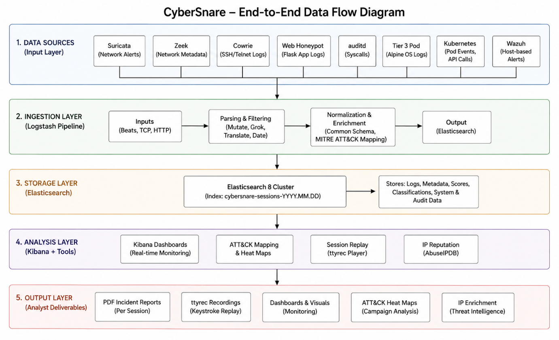
Figure 7.1: END TO END DATA FLOW DIAGRAM

8. High-Level System Components
CyberSnare is composed of seven integrated modules. Each module has a defined responsibility and communicates with adjacent modules through structured interfaces. The design ensures that components can be developed and tested independently before integration
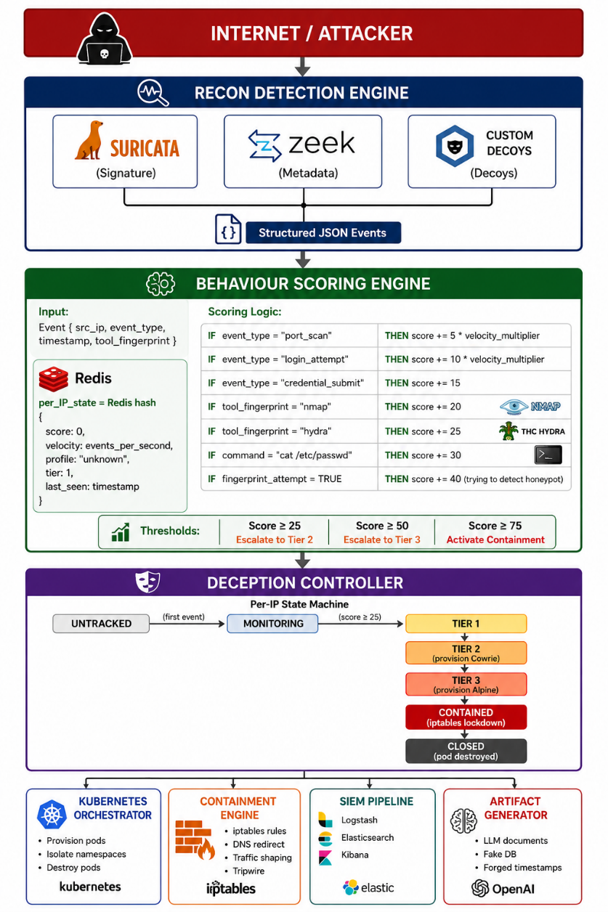
Figure 8.1: System architecture diagram

8.1 Recon Detection Engine
The recon detection engine forms the outermost visibility layer of the platform. It monitors all incoming network traffic and generates structured event data consumed by the scoring engine.
Suricata 6 operates in IDS mode with the Emerging Threats community ruleset. It detects port scans, brute-force attempts, and known attack tool signatures, publishing each alert as a structured JSON event.
Zeek 5 operates in parallel, generating structured logs that signature-based detection cannot produce, full connection records, DNS queries, HTTP sessions, SSH handshake details, and file transfer metadata. Together, both tools ensure that an attacker who evades one detection method is still observed by the other.

8.2 Behaviour Scoring Engine
The scoring engine transforms raw network events into actionable escalation decisions. It is implemented in Python 3.11 with Redis 7 as the in-memory state store.
Each event type carries a base score, adjusted by a velocity multiplier so that rapid automated activity scores higher than slow human interaction. This correctly distinguishes automated scanners from skilled human operators without manual tuning. The engine also maintains a three-profile attacker classifier, assigning each session as an automated tool, script kiddie, or skilled human, based on timing regularity, command patterns, and tool fingerprints.
Score thresholds drive all escalation decisions: score 25 triggers Tier 2, score 50 triggers Tier 3, and score 75 activates full containment mode.

8.3 Deception Controller
The deception controller is the central coordination point of the entire platform. It is implemented as a FastAPI Python service running a per-IP state machine with seven states: UNTRACKED, MONITORING, TIER1, TIER2, TIER3, CONTAINED, and CLOSED.
Every escalation decision, pod provisioning call, containment rule application, and SIEM state-transition event passes through the controller. It receives score threshold events from the scoring engine, calls the Kubernetes Python client API to provision or destroy pods, applies or removes containment rules, and exposes session state through a REST API consumed by the Kibana dashboard for real-time analyst monitoring.

8.4 Kubernetes Orchestrator
The Kubernetes orchestrator manages the full lifecycle of all honeypot pods using k3s, a lightweight certified Kubernetes distribution operating within laboratory hardware constraints.
All honeypot pods run with the gVisor (runsc) container runtime, which intercepts system calls before they reach the host kernel and significantly reduces container escape risk. Tier 1 decoys run as permanent Deployments. Tier 2 and Tier 3 environments are provisioned as on-demand Jobs, each in a dedicated namespace that isolates concurrent sessions at both the network and filesystem level. Resource limits are applied per pod to prevent resource exhaustion. A maximum of three concurrent Tier 3 sessions are supported, additional sessions queue at Tier 2 until capacity is available.

8.5 AI Artifact Generator
The artifact generator produces complete fake enterprise environments before any Tier 3 session is exposed. It operates from a master company profile JSON object that defines all organisational parameters, company name, industry, founding date, employee roster, department structure, internal IP scheme, and server inventory.
The generation pipeline produces four categories of content:
- Prose documents: internal memos, project reports, budget emails, and HR communications generated via LLM API with the company profile as mandatory context
- Structured records: employee databases, customer tables, and financial data generated using Python Faker constrained to the profile name pool
- System artifacts: shell histories, authentication logs, and cron logs generated through a template engine with timestamps calculated backwards from the deployment date
- Configuration files: SSH config, crontab entries, and /etc/hosts referencing internal addresses from the profile
Filesystem timestamps are forged using libfaketime, the Linux touch command, and debugfs to manipulate all three Linux timestamp fields. A second-pass LLM consistency check validates the full artifact set for internal contradictions before deployment.

8.6 Dynamic Containment Engine
The containment engine ensures no attacker activity escapes the deception environment. It is applied to every Tier 2 and Tier 3 pod immediately on provisioning, before the attacker gains access. The following mechanisms are applied in combination:
- iptables OUTPUT chain rules block all real outbound internet access from the pod
- DNAT rules redirect connection attempts to internal deception containers, so pivot attempts appear to succeed but reach more deception
- dnsmasq provides an internal DNS server resolving fake company domains to deception container addresses
- tc and netem introduce 50 to 200 milliseconds of artificial latency and bandwidth limits, simulating aged hardware and adding environmental realism
- Linux network namespaces provide per-session network isolation, preventing cross-session observation

8.7 SIEM and Intelligence Platform
Elasticsearch 8 stores all session events indexed by ID and timestamp, while Logstash 8 normalizes logs from all sources into a common JSON schema. Wazuh 4 agents provide host-based correlation on honeypot pods, and the MITRE ATT&CK mapping module enriches every event with technique IDs and tactic metadata. Kibana 8 dashboards display real-time attack timelines, escalation paths, ATT&CK heat maps, and engagement statistics with ttyrec session replay. Python ReportLab automatically generates structured PDF incident reports on session close, while AbuseIPDB enriches attacker IPs with reputation scores, attack categories, and country of origin.
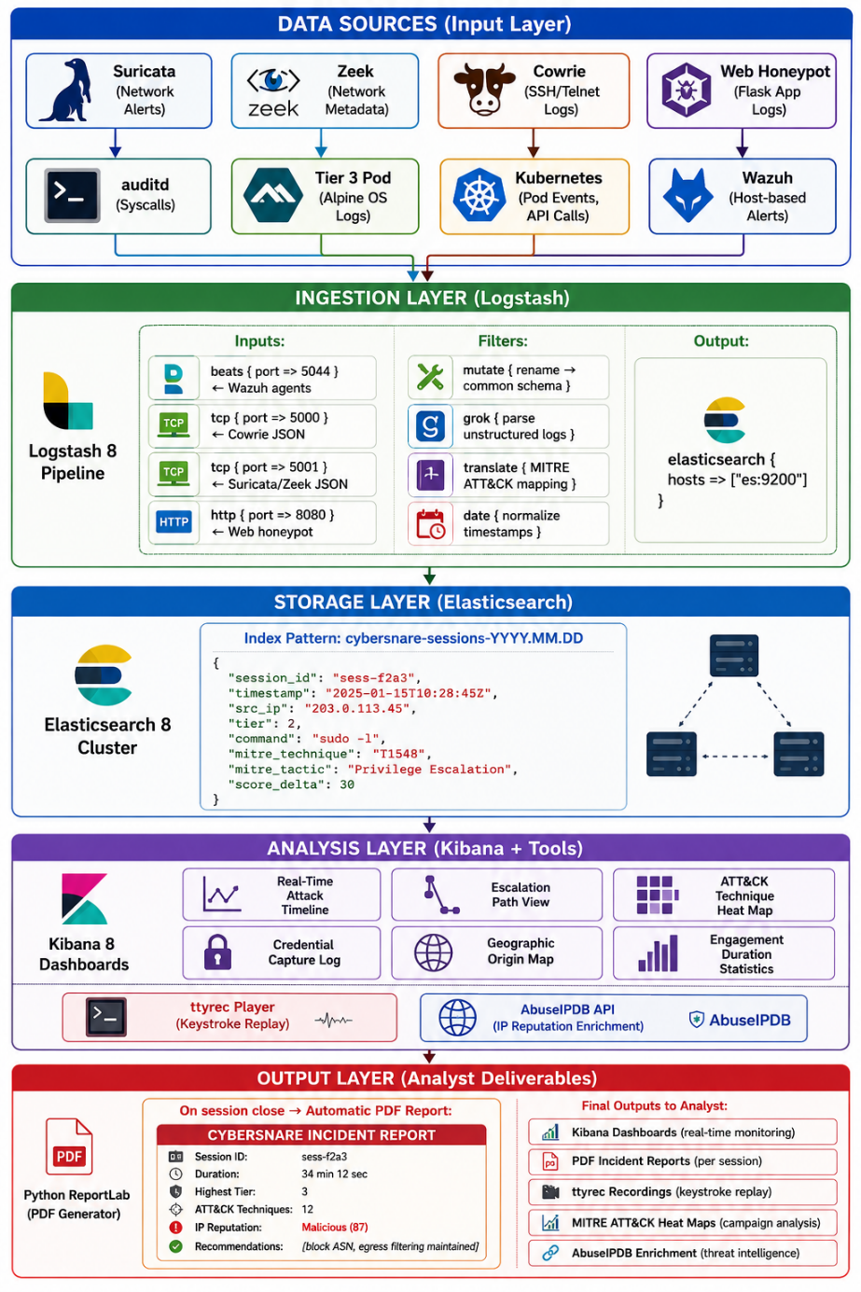
Figure 8.2 — SIEM data pipeline showing how data flows from all sources through to analyst outputs.

9. Use Case Diagram

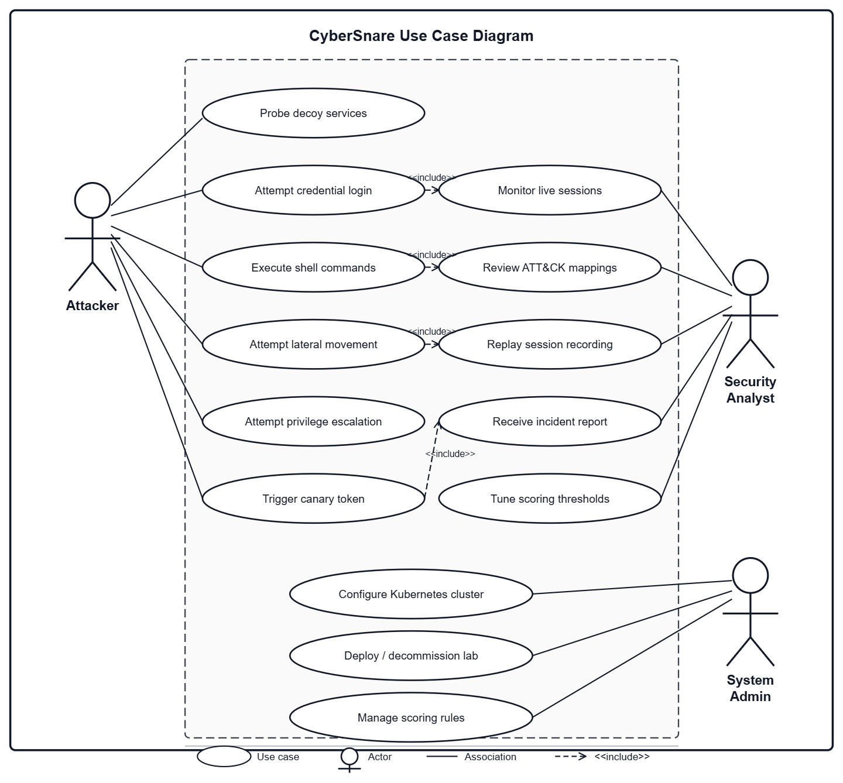

10. Results and Experiments

10.1 Research and Conceptual Outcomes
During the FYP-I phase, no practical implementation has been undertaken. The work completed in this phase is entirely research, analysis, and design oriented, forming the foundation upon which implementation will proceed in FYP-II.
- Comprehensive literature review and gap analysis completed. A thorough review of published academic work across honeypot systems, adaptive deception platforms, machine learning integration, and threat intelligence frameworks was conducted. Five specific research gaps in existing open-source tooling were identified and documented, establishing the academic justification for CyberSnare's design.
- System architecture and component design finalised. The full seven-module architecture of CyberSnare was designed, including the three-tier deception structure, behavioural scoring logic, Kubernetes orchestration approach, AI artifact generation pipeline, dynamic containment mechanisms, and SIEM integration strategy. All inter-module communication interfaces and data flows were defined.
- Technology stack evaluated and selected. Each tool in CyberSnare's technology stack was evaluated against alternatives and selected for specific technical reasons. Key decisions including k3s over full Kubernetes, gVisor for container hardening, Cowrie as the Tier 2 core, and the master company profile consistency mechanism were all analysed, justified, and documented.

10.2 Challenges Identified and Addressed
- Container escape risk identified as a critical limitation. Through research into container security vulnerabilities, container escape was identified as the principal security risk of running attacker-controlled code inside Docker containers. This challenge was addressed in the design phase by incorporating gVisor runtime hardening, tripwire escape detection, and a documented scope boundary acknowledging this as a mitigated but not fully eliminated constraint.
- AI artifact consistency problem identified and solved at design level. Early analysis of LLM-based content generation revealed that multiple independent API calls produce inconsistent content — mismatched company names, contradictory employee references, and varying writing styles. The master company profile JSON architecture was designed specifically to solve this, with a second-pass consistency validation step added to the generation pipeline.
- Hardware and resource constraints evaluated and mitigated. The full CyberSnare architecture requires significant hardware resources. Through careful evaluation, k3s was selected to reduce Kubernetes overhead, a maximum concurrent session limit of three Tier 3 sessions was defined, and a cloud burst option to AWS EC2 was documented as a scalability fallback, ensuring the platform remains deployable within typical academic laboratory hardware.

11. Tools and Technologies
CyberSnare integrates a broad set of open-source tools across seven functional layers. Each tool was selected for a specific technical reason rather than general familiarity. The sections below describe the complete technology stack, organised by platform layer.

11.1 Infrastructure
The laboratory environment runs entirely on Ubuntu 22.04 LTS, selected for its long-term support guarantee and compatibility with k3s, Docker, and the full security tooling ecosystem. Virtual machine isolation is provided through VirtualBox or KVM, separating each functional role attacker, honeypot cluster, and SIEM onto dedicated virtualised hosts. pfSense 2.7 handles gateway and firewall functions, enforcing network segmentation between lab zones. The Kali Linux 2024.x attacker VM provides the full penetration testing toolkit used during red team evaluation scenarios.
Tool | Version | Role
Ubuntu | 22.04 LTS | Host OS across all nodes
VirtualBox / KVM | Latest stable | VM isolation
OPNSense | 2.7 | Gateway and firewall
Kali Linux | 2024.x | Attacker simulation

11.2 Containerisation and Orchestration
Container orchestration is the backbone of CyberSnare's elastic honeypot lifecycle. Docker provides the container runtime. k3s a lightweight certified Kubernetes distribution, manages pod provisioning, namespace isolation, and automated destruction, operating within the memory constraints of academic lab hardware. All honeypot pods run under the gVisor (runsc) runtime, which intercepts system calls before they reach the host kernel, significantly reducing container escape risk.
- k3s was chosen over full Kubernetes specifically because it runs the control plane in under 512 MB RAM, critical for lab deployment.
- gVisor is the primary container escape mitigation, replacing hardware VM isolation for Tier 2 and Tier 3 pods.

11.3 Network Detection
Two complementary tools form the recon detection engine. Suricata applies signature-based rules to detect port scans, brute-force patterns, and known attack tool fingerprints. Zeek operates in parallel, generating structured connection logs, DNS queries, HTTP sessions, and SSH metadata that signature detection alone cannot produce. Together they ensure an attacker who evades one detection method is still captured by the other.

Tool | Version | Purpose
Suricata | 6.x | Signature-based intrusion detection
Zeek | 5.x | Structured network traffic analysis

11.4 Honeypot Components
The honeypot layer spans three distinct environments across the deception tiers.
- Cowrie 2.5+:SSH and Telnet honeypot forming the core of Tier 2. Selected for its detailed session logging, active community maintenance, and Python plugin architecture that allows custom command handler extensions.
- Flask 3.x: Used to build the custom web application honeypot, presenting a convincing corporate login portal, fake admin dashboard, and fake API endpoints.
- Alpine Linux 3.18: Minimal real operating system base for Tier 3 containers. Its small image size reduces pod startup time while providing a genuine shell environment that passes all fingerprinting checks.
- auditd 3.x: Deployed on Tier 3 pods to log every system call, file access, and executed command at the kernel level, forwarding structured events to the SIEM pipeline.

11.5 Behavioural Analysis and Orchestration
The scoring engine, deception controller, and artifact generator are all built in Python 3.11. FastAPI provides the REST API framework for the controller service, chosen for its native async support and high throughput under event-driven workloads. Redis 7 maintains per-IP scores and session state in memory, enabling the time-windowed velocity calculations that distinguish automated tools from human operators. The Kubernetes Python client library (v28.x) handles all pod lifecycle API calls from the controller.

Tool | Version | Purpose
Python | 3.11 | Primary development language
FastAPI | 0.104+ | Deception controller REST API
Redis | 7.x | In-memory scoring state store
Kubernetes Python client | 28.x | Pod lifecycle API calls

11.6 AI Artifact Generation
The artifact generation module combines five tools to produce a complete fake enterprise environment
Tool | Purpose
Claude API / OpenAI API | Prose document generation, memos, reports, emails, HR communications
Python Faker | Structured fake data, employee names, emails, addresses, financial figures
libfaketime | Process-level clock manipulation for filesystem timestamp forgery
Linux touch -t | atime and mtime manipulation on generated files
Python ReportLab | Automated PDF incident report generation on session close
canarytokens.org | Embeddable tokens in fake documents and credentials that alert on access

11.7 Dynamic Containment
Four tools work in combination to ensure no attacker activity escapes the deception environment.
- Iptables: OUTPUT chain rules block real outbound internet access. DNAT rules redirect pivot attempts to internal deception containers so that failed connections never reveal the sandbox boundary.
- tc / netem: Traffic shaping introduces 50–200 ms of artificial latency and configurable bandwidth limits, making the fake server feel like aged, loaded hardware.
- Dnsmasq: Provides an internal DNS server resolving fake company domains to deception containers, transparently redirecting domain-based lateral movement.

11.8 SIEM and Intelligence
The intelligence platform is built on the ELK Stack 8, with Wazuh providing host-based event correlation on top.
Tool | Version | Purpose
Elasticsearch | 8.x | Log storage and search, indexed by session ID and timestamp
Logstash | 8.x | Ingestion pipeline with custom filter plugins per source
Kibana | 8.x | Real-time dashboards, ATT&CK heat maps, session timelines
ttyrec | Latest | Terminal session recording for keystroke-level replay
AbuseIPDB API | v2 | Real-time IP reputation enrichment per new attacker IP

12. Sustainable Development Goals
SDG 9: Industry, Innovation and Infrastructure
CyberSnare directly advances innovation in cybersecurity infrastructure. Commercial adaptive deception platforms cost tens of thousands of dollars annually, placing them entirely beyond reach for small organisations, universities, and public institutions in developing economies including Pakistan. By building an open-source research-grade implementation, CyberSnare makes sophisticated threat intelligence capabilities freely available to any organisation with modest hardware.
Contributions:
- Open-source publication making advanced deception capabilities freely available
- k3s-based architecture deployable on standard academic lab hardware
- Full deployment documentation enabling replication by other institutions
- Practical demonstration of Kubernetes-native security infrastructure at low cost
SDG 16: Peace, Justice and Strong Institutions
Cybersecurity is a matter of institutional integrity. Government systems, financial institutions, healthcare providers, and public utilities all depend on secure digital infrastructure. In Pakistan, institutions including NADRA, banking sector organisations, and government networks face documented threat actor activity. Tools that help defenders understand attacker techniques enable more informed security decisions, strengthening institutional resilience.
Contributions:
- Platform generates ATT&CK-mapped threat intelligence directly usable by security teams
- Open publication contributes to national cybersecurity research capacity
- Understanding attacker TTPs enables proactive rather than purely reactive defence
SDG 17: Partnerships for the Goals
CyberSnare is designed to facilitate knowledge sharing across research institutions. Publishing the platform with full documentation invites other researchers, universities, and practitioners to extend and build upon it. Integration of established open-source components, Cowrie, Suricata, Zeek, ELK Stack , reflects the principle of building on collaborative global effort. Canarytokens.org integration connects CyberSnare to the broader open security community.

13. Gantt Chart
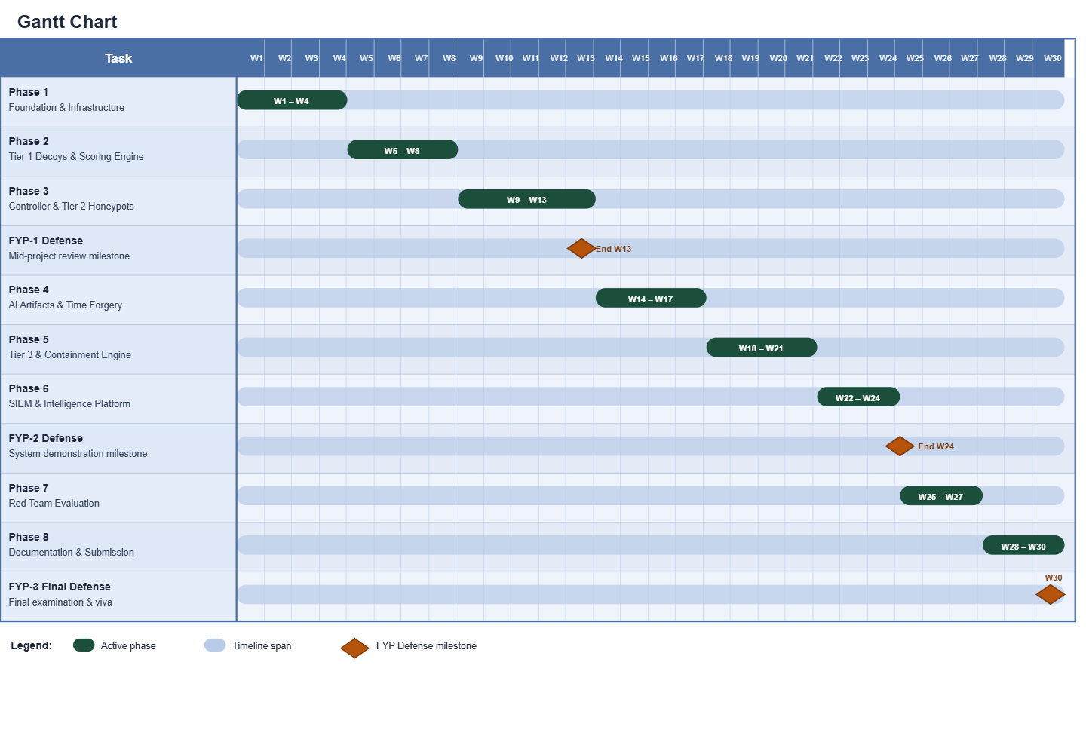

14. Expertise of Team Members
Eman Azam: Project Lead & Backend Developer
- Linux Containment Internals: iptables (OUTPUT/DNAT), network namespaces, tc/netem, libfaketime, debugfs.
- Suricata + Zeek — IDS rule writing (Emerging Threats), custom Zeek scripts for DNS/HTTP/SSH logs.
- Network Containment — iptables DNAT redirection, dnsmasq, tc/netem latency (50–200ms), per-session namespaces.
Uliya Fatima : Infrastructure & Security Engineer
- k3s + gVisor — Cluster administration, runtime class config, pod networking, multi-tenancy isolation.
- Suricata + Zeek — IDS rule writing (Emerging Threats), custom Zeek scripts for DNS/HTTP/SSH logs.
- Kubernetes Python Client: Pod lifecycle management (Jobs/Deployments), namespaces, resource limits, gVisor runtime in k3s.
- LLM + Synthetic Data: API orchestration with profile context, Python Faker, template engine for documents/logs/configs.
Sara Sultan : SIEM & Intelligence Developer
- ELK Stack 8 : Elasticsearch, Logstash , common JSON schema normalisation.
- MITRE ATT&CK: Technique ID + tactic name enrichment per event via Logstash plugin.
- Reporting + Enrichment — Python Reporting Lab PDFs, AbuseIPDB API, ttyrec replay integration.

15. References:
Spitzner, L. (2003). Honeypots: Catching the Insider Threat. Proceedings of the 19th Annual Computer Security Applications Conference (ACSAC), Las Vegas, USA, pp. 170–179. https://doi.org/10.1109/CSAC.2003.1254322
Mokube, I. and Adams, M. (2007). Honeypots: Concepts, Approaches, and Challenges. Proceedings of the 45th Annual ACM Southeast Conference, Winston-Salem, USA, pp. 321–326. https://doi.org/10.1145/1233341.1233399
Kuwatly, I., Sraj, M., Al Masri, Z. and Artail, H. (2004). A Dynamic Honeypot Design for Intrusion Detection. Proceedings of the IEEE/ACS International Conference on Pervasive Services, pp. 95–104. https://doi.org/10.1109/PERSER.2004.1356776
Wang, C. and Lu, Z. (2018). Cyber Deception: Overview and the Road Ahead. IEEE Security and Privacy, 16(2), pp. 80–85. https://doi.org/10.1109/MSP.2018.1870866
Morić, Z., Dakić, V. and Regvart, D. (2025). Advancing Cybersecurity with Honeypots and Deception Strategies. Informatics, 12(1), 14. https://doi.org/10.3390/informatics12010014
Lanz, S., Pignol, S.L-R., Schmitt, P., Wang, H., Papaioannou, M., Choudhary, G. and Dragoni, N. (2025). Optimizing Internet of Things Honeypots with Machine Learning: A Review. Applied Sciences, 15(10), 5251. https://doi.org/10.3390/app15105251
Rabzelj, M. and Sedlar, U. (2025). Beyond the Leak: Analyzing the Real-World Exploitation of Stolen Credentials Using Honeypots. Sensors, 25(12), 3676. https://doi.org/10.3390/s25123676
Aradi, Z. and Bánáti, A. (2025). The Role of Honeypots in Modern Cybersecurity Strategies. Proceedings of the IEEE 23rd World Symposium on Applied Machine Intelligence and Informatics (SAMI), Stará Lesná, Slovakia. https://doi.org/10.1109/SAMI63904.2025.10883300
Hegedüs, D.L., Balogh, Á., Érsok, M., Erdődi, L., Olcsák, L. and Bánáti, A. (2024). Beyond Static Defense: Dynamic Honeypots for Proactive Threat Engagement. Proceedings of the IEEE 18th International Symposium on Applied Computational Intelligence and Informatics (SACI), Timisoara, Romania, pp. 547–552. https://doi.org/10.1109/SACI60582.2024.10619888
Sladić, M., Valeros, V., Catania, C. and Garcia, S. (2023). LLM in the Shell: Generative Honeypots. arXiv preprint, arXiv:2309.00155. https://doi.org/10.48550/arXiv.2309.00155
Wang, Z., You, J., Wang, H., Yuan, T., Lv, S., Wang, Y. and Sun, L. (2024). HoneyGPT: Breaking the Trilemma in Terminal Honeypots with Large Language Model. arXiv preprint, arXiv:2406.01882. https://doi.org/10.48550/arXiv.2406.01882
Danilov, V., Ovasapyan, T., Ivanov, D.V., Konoplev, A.S. and Moskvin, D.A. (2022). Generation of Synthetic Data for Honeypot Systems Using Deep Learning Methods. Automation and Remote Control in Computer Science, 56, pp. 916–926. https://doi.org/10.1134/S0005117922060029
Anwar, A.H., Kamhoua, C.A., Leslie, N.O. and Kiekintveld, C. (2022). Honeypot Allocation for Cyber Deception Under Uncertainty. IEEE Transactions on Network and Service Management, 19(4), pp. 3438–3452. https://doi.org/10.1109/TNSM.2022.3160904
Florea, R. and Craus, M. (2022). A Game-Theoretic Approach for Network Security Using Honeypots. Future Internet, 14(12), 362. https://doi.org/10.3390/fi14120362
Aggarwal, P., Du, Y., Singh, K. and Gonzalez, C. (2021). Decoys in Cybersecurity: An Exploratory Study to Test the Effectiveness of 2-Sided Deception. arXiv preprint, arXiv:2108.11037. https://doi.org/10.48550/arXiv.2108.11037
Guan, C., Liu, H., Cao, G., Zhu, S. and La Porta, T. (2023). HoneyIoT: Adaptive High-Interaction Honeypot for IoT Devices Through Reinforcement Learning. Proceedings of the 16th ACM Conference on Security and Privacy in Wireless and Mobile Networks, Guildford, UK, pp. 49–59. https://doi.org/10.1145/3558482.3590180
Franco, J., Aris, A., Babun, L. and Uluagac, A.S. (2022). S-Pot: A Smart Honeypot Framework with Dynamic Rule Configuration for SDN. Proceedings of the IEEE Global Communications Conference (GLOBECOM), Rio de Janeiro, Brazil, pp. 2818–2824. https://doi.org/10.1109/GLOBECOM48099.2022.10001252
Touch, S. and Colin, J-N. (2021). ASGuard: Adaptive Self-Guarded Honeypot. Proceedings of the 17th International Conference on Web Information Systems and Technologies (WEBIST), Online, pp. 565–574. https://doi.org/10.5220/0010654100003058
Nintsiou, M., Grigoriou, E., Karypidis, P.A., Saoulidis, T., Fountoukidis, E. and Sarigiannidis, P. (2023). Threat Intelligence Using Digital Twin Honeypots in Cybersecurity. Proceedings of the IEEE International Conference on Cyber Security and Resilience (CSR), Venice, Italy, pp. 530–537. https://doi.org/10.1109/CSR57506.2023.10224941

